**Practical No: 07**

**Aim: Implement Decision Tree Classifier**

**Code:**

import pandas as pd

from sklearn.tree import DecisionTreeClassifier

from sklearn .model_selection import train_test_split

from sklearn import metrics

from matplotlib import pyplot as plt

from sklearn import tree

col_names = ['Reservation', 'Raining', 'BadService','Saturday','Result']

hoteldata = pd.read_csv("dtree.csv", header=None, names=col_names)

feature_cols = ['Reservation', 'Raining', 'BadService','Saturday']

X = hoteldata[feature_cols]

y = hoteldata.Result

X_train, X_test, y_train, y_test = train_test_split(X, y,test_size=0.3, random_state=1)

print(hoteldata)

print("x train data: ", X_train)

print("y train data: ",y_train)

print("x test data: ", X_test)

print("y test data: ",y_test)

clf = DecisionTreeClassifier(criterion="entropy", max_depth=5)

clf = clf.fit(X_train,y_train)

y_pred = clf.predict(X_test)

print("ytest = ", X_test)

print("ypred = ", y_pred)

print("Accuracy:",metrics.accuracy_score(y_test, y_pred))

fig = plt.figure(figsize=(25,20))

t = tree.plot_tree(clf,feature_names=feature_cols,class_names=['Leave','Wait'],filled=True)

fig.savefig("decistion_tree.png")

**Output:**

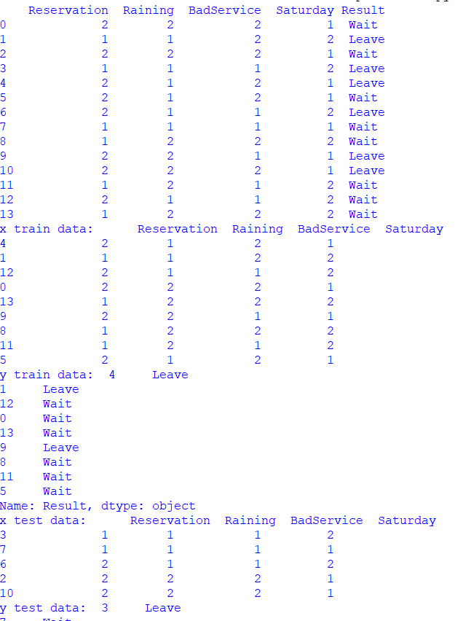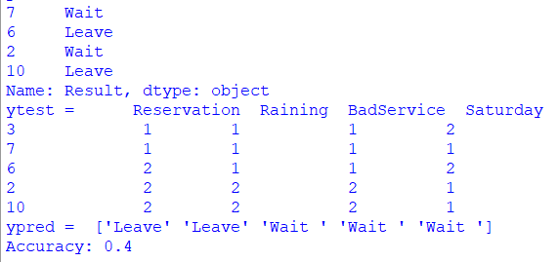

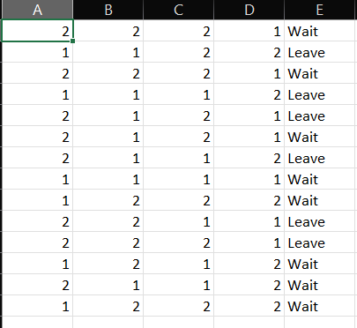**dtree.csv**

**dtree.png**

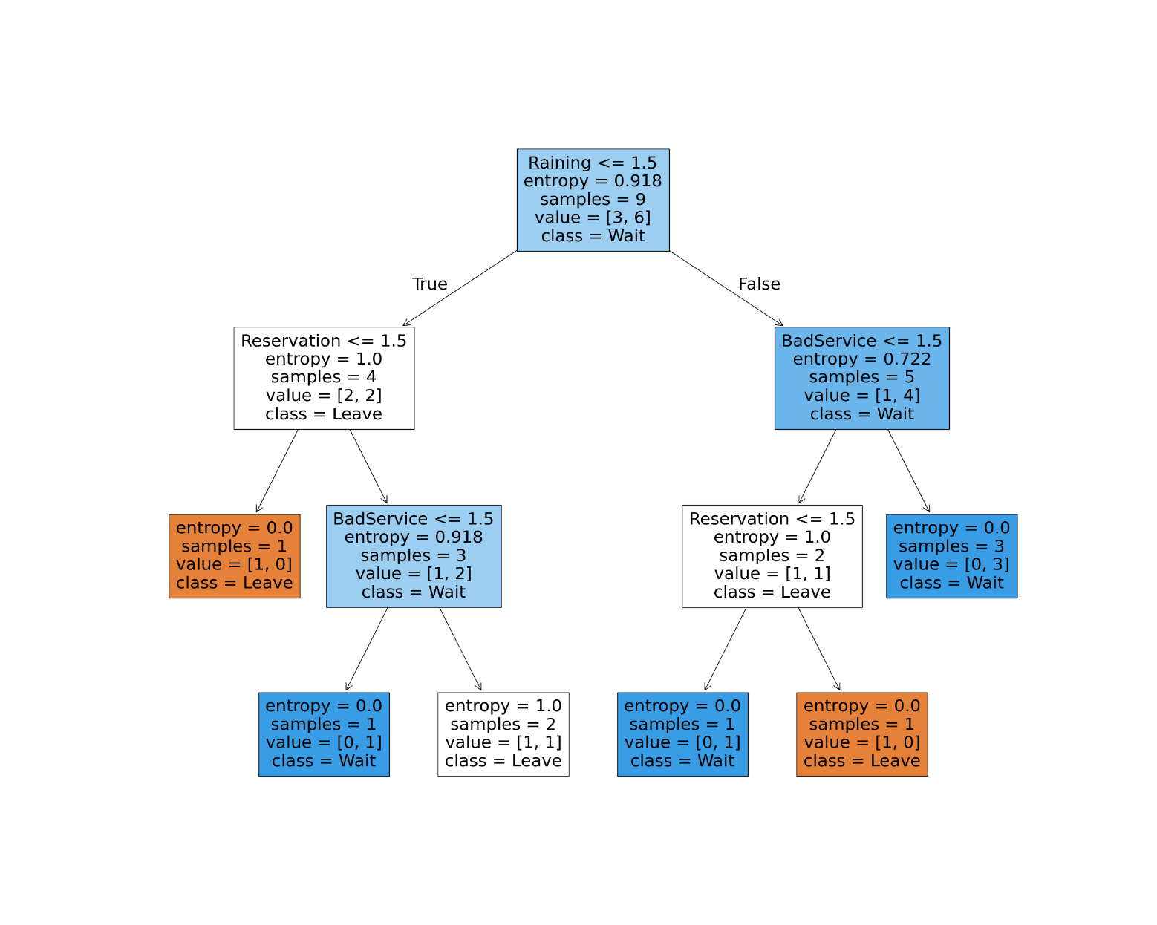

**Note:** Save the excel file in .csv Extension ,Save the .py and .csv file in same folder.